ST IVES UNITING CHURCH – Fifty Memorable Years

The Ministers

Associate Ministers and Lay Preachers

Early Days

Church Union

Adult Christian Education

Fellowship

Children and Youth Activities

Funds for the Church

Service to the Church and Congregation

Service to the Wider Community

The Future

A word from the minister in 2013

1960’s Australia was an extraordinary time. We had over 4,000,000 births between 1946 and 1961. Over one million migrants came to call Australia home between 1946 and 1955. With Australia’s booming population came a boom in housing. St Ives was one Australia’s most rapidly growing new housing areas, with “the cheapest sewered land in Sydney”.

As sleepy semi-rural St Ives burst into new life with families filling new houses, other social capital also sprang up. Notably, many public and private schools were built or expanded. The churches recognised the opportunities for worship, mission and service that St Ives represented.

1963 is a key marker in our history. There had long been Methodist churches in the area, as well as being served by the Pymble Presbyterian church, yet 1963 was a new beginning. The new Methodist Church building was opened in 1963 as a-state-of-the-art complex for contemporary worship and Christian education. The Presbyterian congregation that met on the St Ives Uniting Church’s current site was made an independent congregation in the same year, although its fine new building dated from 1960.

The powerful story that Howard Walker tells in these pages is of how the Methodist and Presbyterian churches responded to God’s call in that time of rapid social change in the 1960’s. We also read of the new venture of faith as the Methodist and Presbyterian congregations came together to become St Ives Uniting Church in 1977.

Fifty years on St Ives is in another period of rapid social change, visible in new faces and types of housing. History not only speaks of the past, but also asks questions about the future. How will we not return to the past, but regain our founders’ sense of adventure as we respond to God’s call in our new environment?

Rev Dr Robert McFarlane

September 2013

ST IVES UNITING CHURCH – Fifty Memorable Years

In 1963, the St Ives Presbyterian Church was established on our present site and, in the same year, the new St Ives Methodist Church was opened and dedicated nearby on Mona Vale Road. At the time of Church Union, the congregation of the Methodist Church made the decision to move to the Presbyterian Church, to form the St Ives Uniting Church. We are now in 2013 celebrating, as our Golden Jubilee, the 50 years of fruitful growth and this very successful and happy union.

The Ministers

St Ives, in 1963, was a serene, bushy, semi-rural Sydney North Shore suburb with a village green and a showground, a suburb where you would still find cows and horses grazing in quiet pastures. It was into this pleasant but fast-growing neighbourhood, in 1963, that Rev Lockhart Finlay, BA, OAM with his wife Carol, son Mark and daughter Michelle moved from Bellingen, a small town on the NSW Mid North Coast where he was Minister of the Presbyterian Church, to take up the role as Minister of the new St Ives Presbyterian Church, a role which he was to hold for the next 28 years.

Lock Finlay was a visionary who, with his alert and insightful mind, quickly realised the abundant potential in this area for a new church to grow and serve the needs of both a thriving congregation and also the wider community. Over the years, he initiated the building of a small church, a Sunday School building, a large, multi-purpose, Seven-day-a-week Church and Christian Community Centre, and its later extension to provide additional accommodation for the Sunday School, mid-week education programmes and some offices. Over this period of building expansions, the Church experienced steady growth in the adult congregation, the Youth Group, and the Sunday School.

Interaction with the community of St Ives was a high priority, and his initiatives included Monday-to-Friday activities in partnership with the YMCA, a Senior Citizens Group, and Christians in Action. Lock Finlay made two study visits to the USA which resulted in the introduction of, amongst other programmes, Bethel Adult Bible Study, the Kamaleson Parish Mission, and the Stephen Ministry.

In addition to his heavy parish duties, Lock Finlay undertook a number of wider Church and community responsibilities, including member of the Stewardship and Promotions Committee of the NSW Presbyterian Assembly (before Church Union), Chairman of the Presbytery of Ku-ring-gai (after Church Union), member of the Council of the Uniting Church NSW Synod and of the Synod Settlements Committee, member of NSW Synod Board of Christian Education, Deputy Chairman of the NSW Synod Board of Mission, and member of the Council of Knox Grammar School. In recognition of his service to religion and the wider community, Lock Finlay was honoured with an award under the Order of Australia.

Throughout the 28 years, Lock Finlay was ably supported by Carol who was an active participant and leader in many of the congregation’s ladies’ activities. We read in his reminiscences: ‘I cannot overemphasise the fact that Carol was my rock and that she supported me in all my endeavours.’

During the period of Lock Finlay’s ministry, from the opening of the new Methodist Church in 1963 until Church Union, the five ministers who served there were: Rev Raymond Diver, Rev Tommy and Mrs Beverley Plaizier, Rev Gordon and Mrs Betty Hickson, Rev Ian and Mrs Audrey Somerville, and Rev John (Jack) Hayes. Tommy Plaizier recalls a very active church with a strong Youth Group and a presentation of Geoffrey Beaumont’s Twentieth Century Folk Mass that filled the Church to capacity. The Church grew in Christian witness in a growing community. The Plaiziers went on to serve in Fiji. Past Methodists in our congregation fondly remember the leadership of Ted Gordon, Harold Julian, and Esther and Tom Deans.

Rev Ian Pearson, BA, Dip Ed, Grad DipTheol was born in Western Samoa and lived for many of his childhood years in Samoa, during which he was taken on visits to Papua New Guinea. These and later cross-cultural experiences as an adult have helped to shape his understanding of and respect for people of different cultures and lifestyles who might have different theological, sociological, and political opinions. Prior to answering the call to St Ives, he had been serving, for seven years, as the Minister of the Burwood-Croydon Uniting Church in inner-western Sydney, with a congregation of 21 different cultures. He, with his wife Helen and their daughters Janette and Anna, moved into the St Ives Manse and was inducted as Minister of the St Ives Uniting Church in April 1993.

During his time at St Ives, Ian Pearson became well known and highly regarded for his diligent and friendly pastoral care: his empathy and willingness to be together with others in their faith journey, their anxieties, griefs, and guilt, and his sharing of these whilst providing gentle guidance and encouragement. His cheerful demeanour and sense of humour were often just what was needed by those he visited in hospitals and homes. Helen Pearson, who was a full-time school teacher, played an active part in the Church’s Sunday School.

In 1995, he introduced the Building Our Tomorrows Together With God programme. This began with Study Groups and a Parish Survey which had the aim of seeking from the congregation comments and suggestions on all aspects of parish life. The responses were then used to assist in developing action plans and specific goals for 16 different initiatives in the areas of Worship, Reaching Community Needs, Community Visibility, and Buildings and Facilities. The programme was successful in creating a new beginning and a sense of common purpose, and set in motion the activities that then worked towards achieving the goals that had been set.

In 2003, Ian Pearson received and accepted the call to be Minister of the Pitt Street Uniting Church, Sydney. His 10 years at St Ives are remembered here as a very productive and happy ministry.

Rev Judith Caldwell was inducted by the Presbytery of Ku-ring-gai as Minister at St Ives in October 2003. During the short time that she was at St Ives, she became known for her commitment and hard work, and demonstrated a great interest in the ministry to children. One of her initiatives was the introduction, especially for young families, of an early Sunday morning church service, before the main service. After eight months with us, Judy Caldwell decided to retire from the St Ives ministry.

Rev Dr Douglas Purnell BA, DMin, OAM, before coming to St Ives in January 2006, had for ten years been Lecturer in Pastoral Theology at the United Theological College, Sydney. Prior to that appointment, he had, for seven years, been the Minister of the Eastwood Uniting Church. He was married to Heather and they had three adult children.

Doug Purnell was the author of three published books: Conversation as Ministry, Exploring Your Family Story, and Working with Families, and published a fourth, Being in Ministry, while he was at St Ives. One of the reviews of this book reads, ‘As if he were painting on one of his canvases, Doug Purnell has created an amazingly detailed landscape that includes his own struggles to reclaim his call to ministry amidst the lived experiences of the people of St. Ives Parish.’ He had also published numerous articles, lectured extensively (outside the UTC), and was a painter of merit, his paintings having been exhibited in many solo and joint exhibitions, both in Australia and the United States.

With his inherent compassion, commitment, and energy, he supplied much appreciated support and encouragement to all our church’s activities and programmes. With his thorough theological knowledge and long ministerial experience, he deepened our understanding of the Gospel and its relevance to our lives. With his vision and creative mind, he challenged us to think ‘outside the square’. With his courage and tenacity, he devised and organised the production of the innovative special events, Stations of the Cross and Stations of Creation, which brought in many hundreds of visitors to the Church, and helped us to understand more clearly the affinity between the wonders and beauty of art and music and the mysteries of religion and our Christian experience. While he was at St Ives, Doug Purnell was the recipient of an award under the Order of Australia for his contributions to the St Ives Uniting Church and the community.

In June 2011, Doug Purnell left our Church to enter retirement, to the regret, but with the warmest wishes, of the whole St Ives congregation.

Rev Dr Robert McFarlane BA, BTh, MEd Lead, PhD, had been the Director of the Uniting Church School of Continuing Education for nine years when he answered the call to become the Minister at St Ives. Prior to that appointment he was, for nine years, Minister of St David’s Uniting Church, Lindfield. In early December 2011, with his wife Andrea and daughter Elissa, he moved into the Manse at St Ives.

In the short time that Rob McFarlane has been at St Ives, he has been active in linking our worship life with the wider community, such as in the Landmark Services for Law and Education, and in developing educational programmes including Uniting Life and Learning, Meet the Neighbours, How the Bible Came to Us, Faith and Science, and Builders and Boomers. Andrea McFarlane has also been busy in starting the Friday Night Group and leading the Children and Families Mission team.

Rob McFarlane’s strong communication skills very soon became evident in both casual intercourse and in his preaching and teaching. In these roles, his ability to impart his deep knowledge with clarity, in a relaxed way and with good humour is greatly appreciated.

Associate Ministers and Lay Preachers

Over the time that Lock Finlay was at St Ives, a number of Associate Ministers were engaged for various periods with the aim of relieving the Minister’s work load and, in some cases, bringing specialist knowledge and experience to the Church. Rev John Bovard was inducted by the Presbytery of Ku-ring-gai in 1972 and was present at the official opening and dedication of the St Ives Presbyterian Church and Community Centre in September 1973. He was concerned primarily with ministry to the young people, and stayed until 1977, at the time of Church Union.

Rev Norman Lickiss LTh who had been Chairman of the Methodist Conference before his retirement, came to St Ives for five months in 1977 and provided valuable assistance, especially in the area of pastoral visitation. Lock Finlay has said that he was a person who ‘loved people and served them with spiritual devotion and deep understanding.’

In early 1978 our Church secured the services, for 12 months, of Rev John Hooper BA, DipRE. He firmly believed that Christianity should be interesting, enjoyable and practical, and provided valuable assistance by taking charge of the Sunday School and helping in pastoral visitation.

Rev Russell Thompson LTh was inducted in February 1979, with a ministry focused on the Sunday School and the Youth Fellowship. He was accompanied by his wife Ann and four children: Ian, Elizabeth, Paul, and Peter. He had worked as a Minister for 12 years in outback NSW before, in 1970, beginning his service as a Flying Padre with the Far West Mission, based in Cobar. He believed that children need both adult models to follow and a caring community in which they can participate and express their own growing faith and, similarly, that young people need values that hold firm in an unpredictable world. Russell Thompson conducted a significant and influential ministry during his four years at St Ives, not only with the children and youth, but also with the adult members of the congregation. He left St Ives in 1984 when he accepted a call to become the Minister of the Cronulla Uniting Church.

Russell Thompson’s place as Associate Minister, also with an emphasis on children and youth, was taken by Rev Werner Haase BA, MDiv Immediately prior to the time that he and his wife Helen and their sons, James and Jonathan, came to St Ives, he had been residing in the USA, was in the middle of his PhD studies, and was about to be ordained as a Minister of the Word. His ordination and his induction into the St Ives Uniting Church took place in July 1985. He too became an effective and influential minister to the children and youth and also to the adult members of the congregation. Lock Finlay and the congregation were sorry to lose him when, in 1988, he departed to serve in joint ministry in Wagga Wagga, serving mostly at Turvey Park but also at times at Kooringal and Wagga Wagga Central Uniting Church.

Later in 1988, Rev Stan Stewart LTh, DipRE, was the next to be appointed as Associate Minister, with a particular focus on ministry in Adult Education. His wife Pauline (neé Hubner) was also appointed, on a part-time basis, to assist in an unordained ministry to children and youth. Pauline was known to the congregation, having worked at St Ives in 1981, before she and Stan were married. They had developed a reputation in the Uniting Church for being a most enterprising and creative couple.

Amongst the successful and worthwhile outcomes of their ministries were Divorce Recovery Workshops, Congregational Dinners with speakers on topical subjects; and musical stage plays such as Nehemiah, Godspell, Jesus Folk, and Stars. They also organised Sights and Sounds of Christmas presentations in which a large variety of Christmas scenes were constructed in the Church and in the many rooms and corners of the complex. Children were bused in from other districts to view these presentations, and the idea and name were taken up by a number of other churches around Australia. During his ministry at St. Ives Stan produced a video, which included members of the congregation, called Greening the Church which was a St Ives initiative that also went out to the wider church. He led a group from the congregation to Indonesia to study the culture and religions of this country, and took a group to participate in the Seventh World Council of Churches Assembly in Canberra.

Stan and Pauline Stewart with their son Walker left St Ives in 1991, at the end of a two-year extension to their original engagement, to take up ministry in New Zealand, where Pauline was subsequently ordained. They left with the congregation’s grateful thanks for the important and innovative work that had been carried out during their time at St Ives.

Our congregation has always been blessed with the presence of a number of highly talented Lay Preachers who have been the source of inspirational messages on days when the Minister has not been available, on special occasions such as Elders’ Services, and in periods when the Parish has been without a Minister. Two whom we still hear regularly are Lawrence Peak and Ian Smith. Others who have in the past been active in this important ministry are Sandra House, Chris Bowen, David Taplin, Don Hagarty, and Alex Smith.

Early Days

The first Presbyterian and Methodist churches in the Pymble-St Ives area were a Methodist Church which was built in 1879 in Pymble and another in St Ives in 1907. In the late 1890s, a Methodist congregation met in a packing shed in Cowan Rd, seated on fruit cases, and the bell from those premises is currently preserved at our Church. The first Presbyterian Church was built in 1895, also in Pymble. In 1962, the Pymble Presbyterian Church Session agreed to a division of charge and for St Ives to be a sanctioned charge from January 1963 with Rev R.A. (Bob) MacArthur, who was the Minister at Pymble, to be the founding Minister at St Ives. In July of that year Lock Finlay took over from Bob MacArthur. The Presbyterian Sunday services and Sunday School classes were conducted in a new, small church building, now the Gillmore Hall, on the present site. The congregation grew rapidly, creating the need to move to two morning services, and the fast-expanding Sunday School necessitated the construction, in 1964, of a small building specifically designed for the these classes.

Over the next five years the church facilities began to become inadequate to cope with the continuing expansion of the congregation, along with the growing population of St Ives. Following much thought and prayer, Lock Finlay presented a development paper on the basic subject of the ministry of our Church which emphasised that the fundamental purpose was to create a Church ‘that will show forth every day of the week the life, character, faith, love and ministry of Christ.’ His concept was a Seven-Day-A-Week Church in which the ministry would continue each day for the entire week. As a consequence, it was decided to erect a multi-purpose building that would be the Church on Sundays and a Christian Community Centre that would meet the needs and interests of all age groups throughout the week. The concept was approved and the architect Jack Hindmarsh, who was a member of the congregation, designed and supervised the construction of a building which comprised a main hall and sanctuary which together were used as the Church on Sundays, but which could be divided into a small closed-off chapel and a large multi-purpose hall which was suitable for many purposes, varying from a gymnasium to classical concerts.

The beautiful windows in the Chapel are by David Saunders and were a gift from the family of Mr Bill Graham whose son Bob was a St Ives Church Elder. The centre of bright yellow represents Christ the Light of the World and then forms the path for the feet of the faithful. The red flames on the feet represent the Holy Spirit and also the redemption by Christ. Green is the symbol of eternal life, and purple the Kingship of Christ. David Saunders also designed the table in the Chapel, the baptismal font, and the pulpit.

On 26th November 1972, the foundation stone was set by the Session Clerk, Mr Colin Gillmore in the presence of the congregation. The new St Ives Presbyterian Church and Christian Community Centre was officially opened and dedicated on 28th October 1973 by the Moderator of the Ku-ring-gai Presbytery, Rev Dr E. Roberts-Thomson.

To ensure that the Seven-Day-A-Week programme in the Christian Community Centre would be professionally administered, agreement was reached with the YMCA for that organisation to manage the Monday-to-Friday programme, beginning in February 1970. As a result, trained YMCA directors and other professional teachers conducted a wide variety of activities such as physical culture, painting classes, musical appreciation groups, courses in public speaking and, for mothers, the study of the developing child. By 1980, the new facility was handling around 1,200 adults and children each week, largely through YMCA activities. The Church’s association with the YMCA worked well until 1987 when, with the mutual recognition that the needs of the community had changed, the YMCA moved to their own premises.

Church Union

Following discussions in the early 1970s, the Congregational Union of Australia, the Methodist Church of Australasia, and the Presbyterian Church of Australia agreed on the merger of the three churches into one, to be called the Uniting Church of Australia. All Methodist congregations entered the Union together with most Presbyterian (including St Ives) and Congregational congregations. The Ministers of the St Ives Presbyterian and Methodist Churches, Lock Finlay and Jack Hayes, began discussing the operation of the forthcoming shared ministry, and organised some combined services of the two congregations. The Inaugural Service of Worship of the St Ives Uniting Church took place in the former Presbyterian Church at 9.15 am on Sunday 26th June 1977. Lock Finlay was the officiating Minister at this service and also at the Youth Service held in the St Ives Wesley Chapel at 7.15 pm. Lock Finlay would have been conducting these services together with Jack Hayes but, unfortunately, on 2nd June 1977, the St Ives Methodist Church, the St Ives Presbyterian Church, and the community generally suffered a great loss in the untimely death of Jack Hayes, their Minister and great friend.

For a few years after Union, some Sunday School classes, church services, and other activities of the newly combined church were held in the former Methodist Church. Then, in March 1980, our Church agreed to Synod’s request that what had become the Wesley Complex of the St Ives Uniting Church be released to the continuing Presbyterian Church. This and the steady growth of the St Ives Uniting congregation resulted in serious accommodation problems. These were overcome by purchasing and demolishing the house which adjoined the western side of the church property and erecting, in 1982, a new wing which comprised three all-purpose rooms, a kitchen, a secretary’s office and two ministers’ vestries. Jim Brown, who was an architect and member of the congregation, designed and supervised the construction of the extensions and also the later ramp and Fellowship Terrace.

Following Union, the previous St Ives Presbyterian and Methodist churches each adopted the procedures and structures of the new Uniting Church of Australia comprising a congregational system of government, with each parish having two councils: one the Council of Elders whose principal concern would be with pastoral matters, and the other the Parish Council which would be concerned with business and property matters. Members of the congregation would come together for an annual meeting and at other times when important matters need to be decided. Parishes would be organised into Presbyteries on a regional basis. State Synods would convene annually and the National Assembly every three years.

In the months leading up to Union, representatives from the St Ives Presbyterian and Methodist Churches had been discussing and making decisions on the organisation and leadership of the new St Ives Uniting Church and it was agreed that, when the two congregations had united, responsibility for the various activities would be as follows:

Minister and Chairman of the Council of Elders – Rev A.L. Finlay
Secretary of Parish Council – Mr S.C. Gillmore
Convenors of:
Ministries of Mission and of Social Activities – Mr John Loder
Ministry of Children and Youth - Mr Jim Hasemer
Ministry of Women – Mrs Betty Bancroft
Ministry of Finance and Property – Mr Hall Metcalf
Ministry of Stewardship – Mr Roy Dowell
Ministry of Community Service – Mr Tom Deans
Ministry of Communication – Mr Bob Knox
Acting Superintendent Sunday School – Mr Ron Brookman
Minister’s Secretary – Mrs Joan Gates
Chairman, Young Adults’ Club – Mr Marty White
Leader, Uniting Church Youth Fellowship – Mr Rod Walker
Organists – Mr H. Wyatt and Mrs N. Booth
YMCA Centre Director – Mr K. Benson.

Adult Christian Education

There has always been a strong emphasis on the importance of Adult Christian Education in our Church at St Ives. Beginning in 1974 under the guidance of Lawrence Peak and Jim Cunningham, and continuing for 25 years, extensive Home Study Groups of 10 to 12 met on various nights throughout the week for what were always stimulating and enjoyable meetings, to discuss a variety of topics such as ‘Prayer’, ‘The Parables of Jesus’, ‘Church Membership’, ‘Church Leadership’ and ‘Sexuality’. Organised by Hugo and Renate Messerle and Angus Bowen, Adult Education Forums were held three or four times each year following Sunday morning worship. These forums featured topics of contemporary interest and importance. In association with the forums, Adult Education Dinners were held annually. Adult Education meetings were held on Friday evenings with visiting speakers which included Tim Costello, Hugh Mackay, Dianne Yerbury, Carl Kruszelnicki, and Father Frank Brennan.

The Bethel Bible Study programme covered the Old Testament in the first year and the New Testament in the second year. The bible study was taught by 14 members of the congregation who had each completed two years of training with the Minister. 100 members enrolled for the two-year course in 1979 and, by the start of its third year, there were well over 100 adult participants every week. Margaret Huxtable graduated as a Teacher in 1987 and maintained oversight of the programme until December 2010, when she was presented, at a worship service, with an award of recognition by Rev Canon Graeme Mac Robb, National Director of the Adult Christian Education Forum.

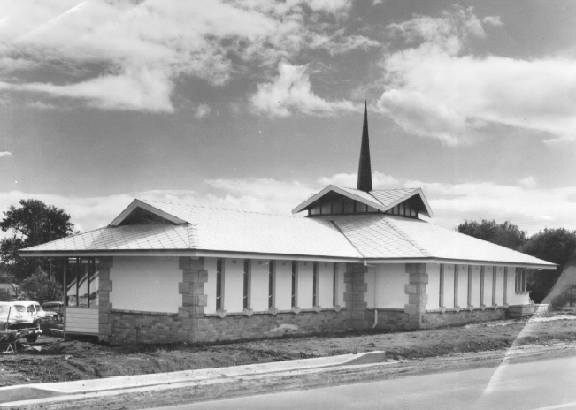

St Ives Presbyterian Church 1963

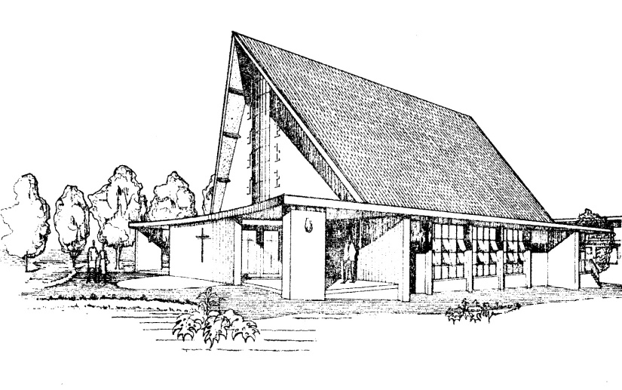
St Ives Methodist Church 1963

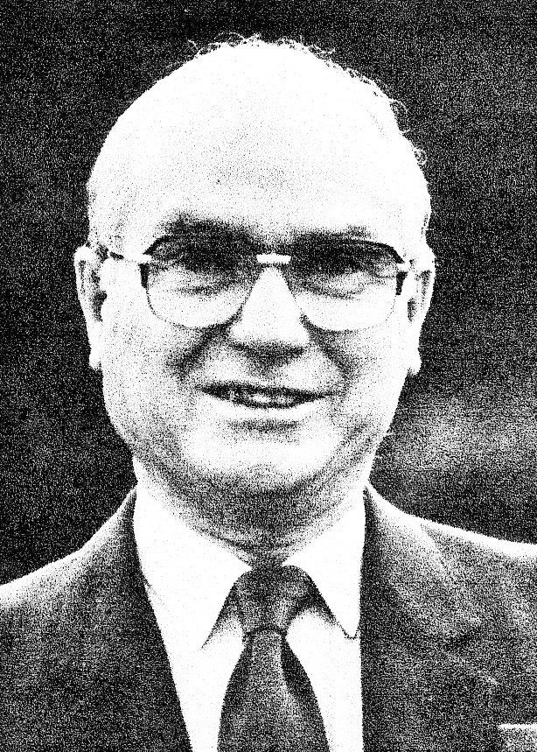

Lock Finlay

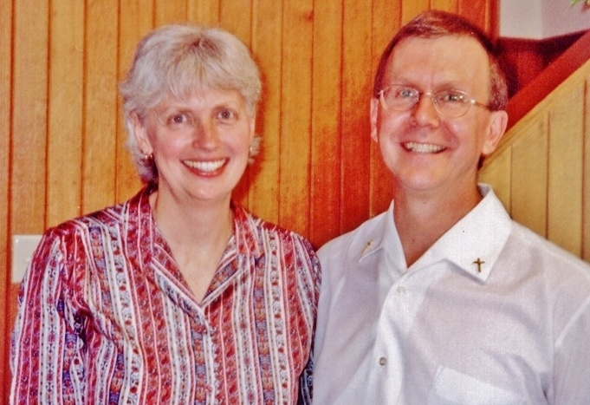
Ian and Helen Pearson

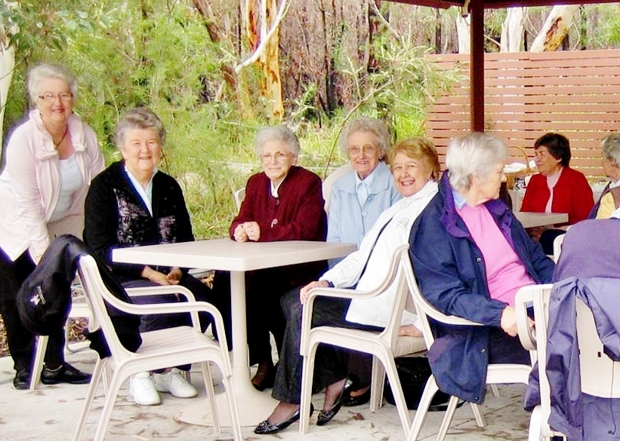

Women’s Day Fellowship

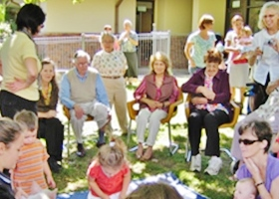

Seniors’ Group with Mums and Moppets

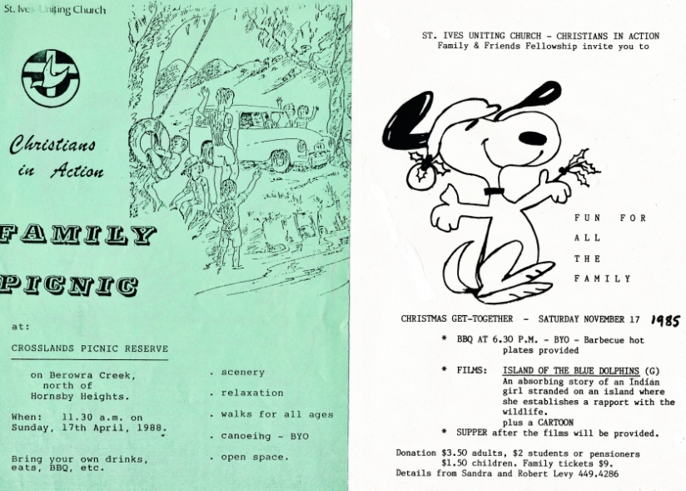

Family Picnic Brochure

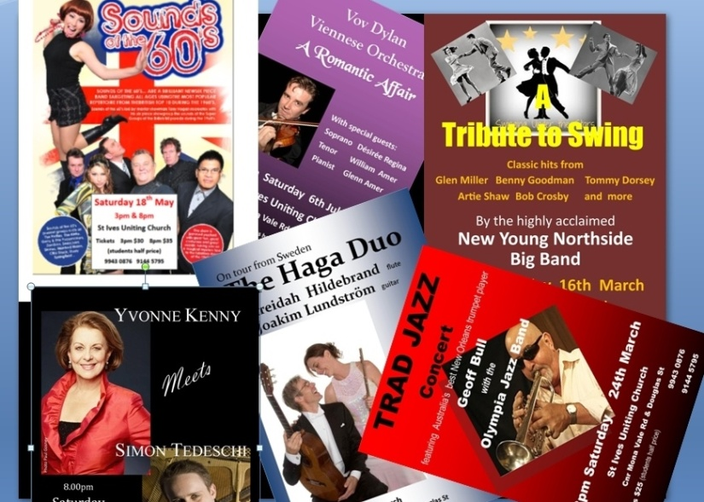

Concert Posters

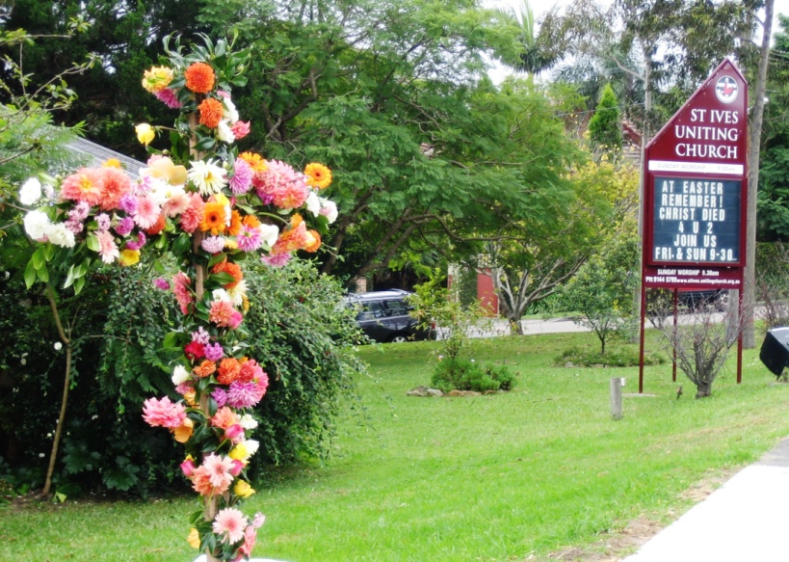

Easter Display Outside the Church

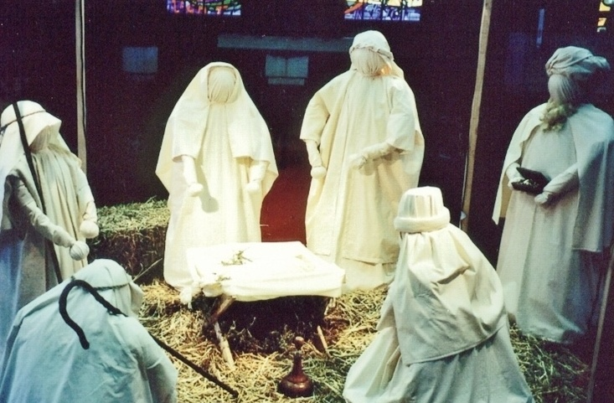

The Nativity

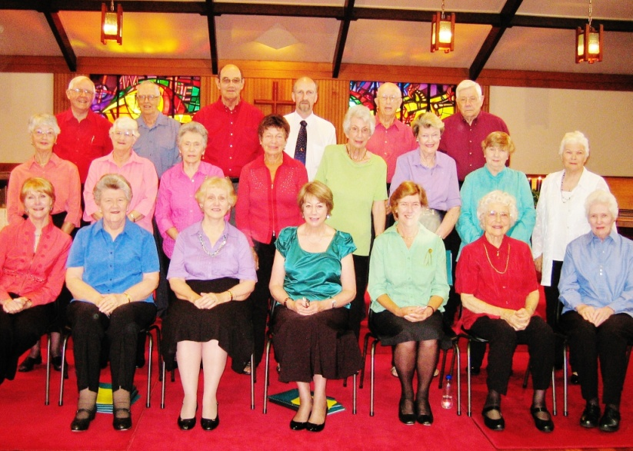

The Choir

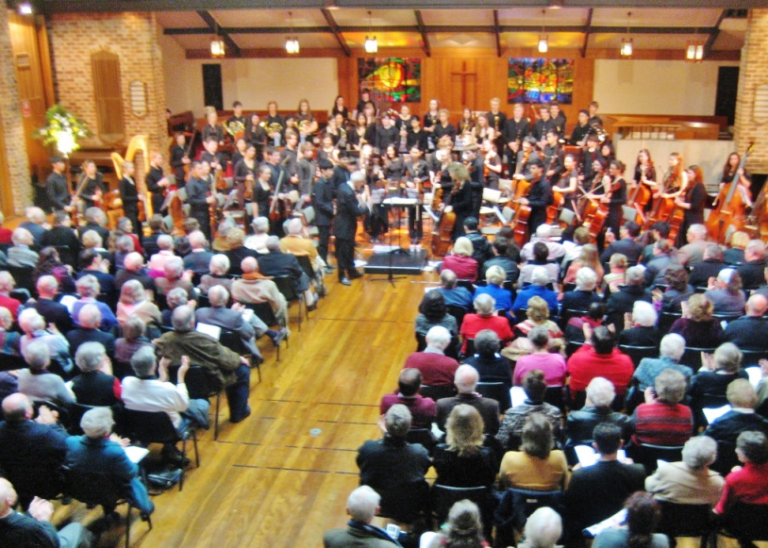

Orchestral Concert

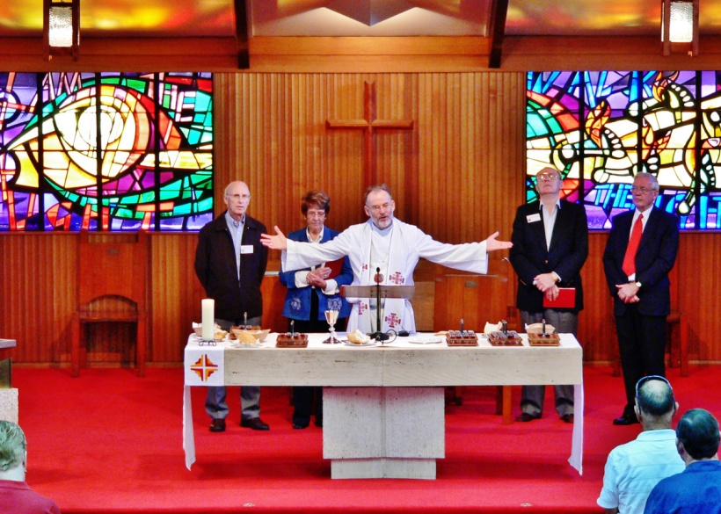

Doug Purnell and Elders at Communion Service

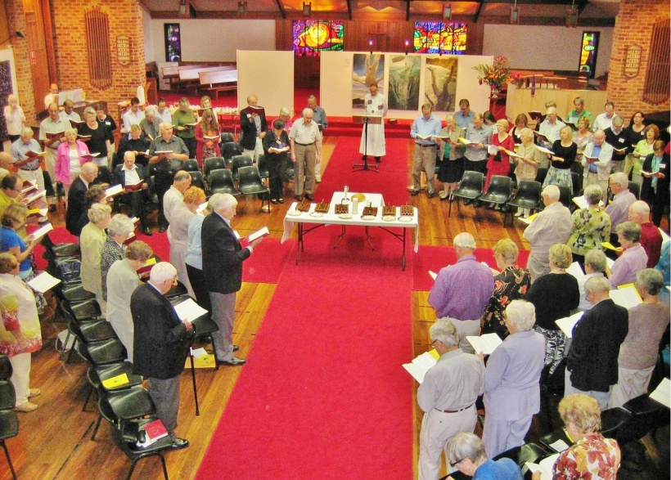

Communion Service during Stations of the Cross

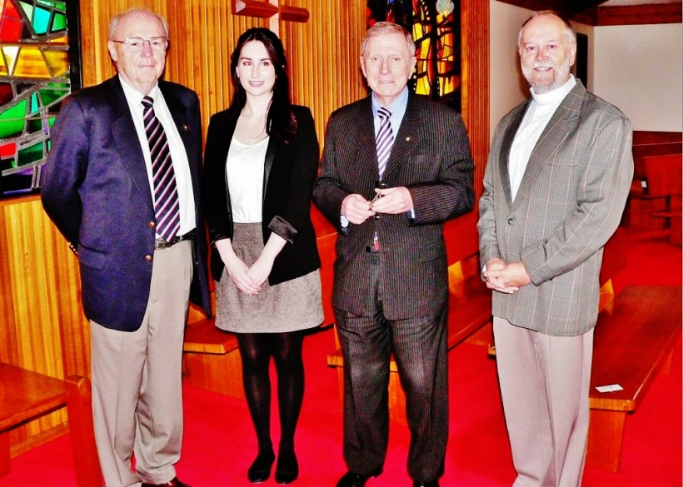

Welcome to our speaker Justice Kirby

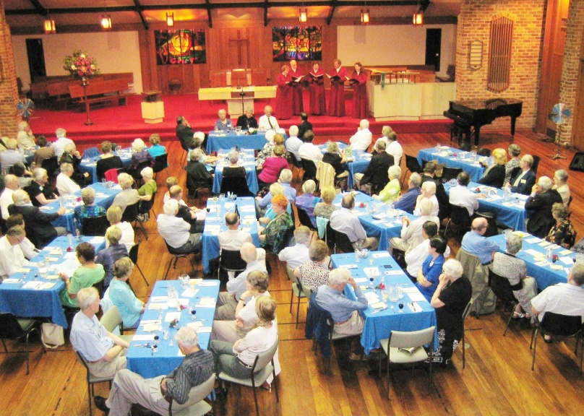

Ecumenical Dinner

The Stephen Ministry is a highly professional teaching programme in which the Stephen Minister teaches members of the congregation on the subject of Pastoral Care. The teacher’s course is an in-depth study of the subject and was taken by both Lock Finlay and Margaret McLelland. They subsequently taught the first course together as Stephen Ministers and, after Lock Finlay retired, Margaret McLelland continued teaching the courses.

In 1979, Rev Dr Sam Kamaleson, who was International Roving Vice President of World Vision and had a distinguished background of world-wide involvement in Mission, Education and the Humanities, visited St Ives as guest preacher. The morning service was followed by an excellent and highly appreciated educational seminar on The Mission of the Church in the Third World. Sam Kamaleson was invited to return to St Ives in 1980 to conduct the Parish (Kamaleson) Mission which ran from Sunday 9th to Wednesday 26th November. He preached each Sunday at both the 9.15 am and 6.30 pm services and also on Monday and Wednesday evenings at 8.00 pm. Lock Finlay’s message in a subsequent Newsletter read, ‘We have come to the end of our Parish Mission which was an inspiring time with Dr Sam Kamaleson and his wife Adela. Sam Kamaleson’s presentation of the biblical message made a very real impact on many of us and brought some of us to think more positively about our commitment to God and about the place of God’s purpose in our lives.’

Ian Pearson introduced the That the World May Know programme in which around 15 people met regularly over 12 months to watch and discuss instructional videos on the Old and New Testaments. Lawrence Peak’s six-session Living the Questions after-church study group started in 2009 and is now in its fifth year. In addition to the material in the Living the Questions programme, the group is currently studying a series put together by World Vision. Next year studies will revert to the Living the Questions material with their newest release, Painting the Stars, covering science and religion.

For many years, Margaret Huxtable has been supervising, and has recently handed over to Tom White, the distribution of the With Love to the World daily Bible reading guide, which is based on the Uniting Church Revised Common Lectionary, and links people’s week-day prayer and Bible study with the Sunday services.

Uniting Life and Learning was launched last year by Rob McFarlane, with the Meet Your Neighbours programme in which we visited two Jewish Synagogues and a Muslim Mosque. Early this year, How the Bible Came to Us introduced the events and text of the Bible from an inclusive and progressive perspective, on four Monday evening sessions. The Faith and Science programme, which met fortnightly on six Monday evenings and was run by Lawrence Peak, demonstrated that there needs to be no conflict between true faith and true science and that, in many ways, they can complement each other and make life that much richer. Builders and Boomers – X, Y, and Z comprises four sessions on understanding generations. The first session attracted members of five other congregations. Other programmes planned for 2013 and 2014 are Meet Your Neighbours (Series 2), Spirituality in Practice, Ethics for Life, and a Holy Land Tour.

Fellowship

One of the prime characteristics of our Church has always been hospitality and the friendly fellowship which is present within the congregation. This has been fostered and enhanced by the activities of a range of congregational groups, some of which have been active since the earliest days but whose titles may have changed over the years. Typical of these are the Women’s Fellowships of which there are currently a morning and an evening group. They meet in love and friendship, in a happy and relaxed atmosphere, and their wide range of activities have included bible study, discussions on worthwhile topics, meetings with speakers, excursions, fund raising, ‘progressive’ dinners in members’ homes, and provision of morning teas, lunches, dinners, and suppers for church functions.

Starting in 1979, Christians in Action (CIA) was, for many years, an active family and friends fellowship whose mission was to provide social and learning activities that bring the whole family together; help for parents in building Christian homes and the Christian faith of their children; experiences of creative worship; involvement in Christian outreach into the wider community; and opportunities for the building of caring and supportive friendships. Activities included picnics, barbecues, camping weekends, dinners, bush dances, film nights, family concerts, discussion groups, and family services.

The Men’s Garden Shed is our Church's men's group, run by Barry Lloyd, which meets three or four times a year, when something comes to mind that would be of real and general interest. Meetings are informal, stimulating and enjoyable, and provide a great opportunity for men of the congregation to form and strengthen friendships. Some of the past events have been a fascinating talk by a 90-year-old RAAF/RAN fighter pilot, the Sydney Heritage Fleet Tour and fish 'n' chips lunch, a visit to the North Head Artillery Museum, and participation, as part of the audience, at the ABC’s Q & A television programme.

The Seniors Group has been operating since the mid-1970s. It meets every Tuesday and provides elderly members with around four hours of fellowship and stimulating entertainment including crafts and quizzes, and lunch is provided. It is currently run by Catholic Community Services and UnitingCare Ageing with the assistance of members of the congregation.

The Craft and Knitting Group, organised by Jeanette Stutchbury, has been active for many years. The crafts that are produced during the year, together with the proceeds of any that are sold, are donated to the Uniting Church and other charities.
Members of the congregation enjoy fellowship with each other, and also with others from outside the Church, in various sporting activities such as bowls and tennis. For a number of years, Badminton and Basketball were played at the Church. Organised by Vic Seaglove, the Golf Programme has been a popular activity for Church members and friends. Games have been played at excellent golf clubs, with special trophy days. The St Ives Church Cricket Team has been playing in the 110-years-old NSW Church Cricket Competition for over 35 years. Rod Walker, who was at that time Leader of the Youth Fellowship and started the team, is still its Captain and is currently also President of the Competition.

Andrea McFarlane started the Friday Night Group in 2012 in response to working-aged women, particularly newer members of the congregation, wishing to support each other on a regular basis, at the end of their busy working weeks. The group expanded to include men at both its bi-monthly get-togethers on Friday nights and the group’s events such as bushwalks, outings, and play performances. The group also provides morning teas after special worship services, runs a stall at the Garage Sales, and supports other mission activities of the Church.

Children and Youth Activities

Until the Wesley Chapel was passed to the continuing Presbyterian Church, the Uniting Church Youth Fellowship, numbering then around 120 young people aged between 15 and 25 years, met there for some years for worship and group studies, after the Sunday evening service. The studies offered an opportunity for members to learn more about the Bible and its relevance in today’s world and to express personal opinions about faith and church life. A variety of social activities were organised, providing greater opportunity for fellowship between the members, including camps and sleepovers for specific and mixed ages. The young people from our Church also attended denominational camps, state conventions, Christian music festivals, and live-in training courses. The Fellowship was involved in community outreach such as financial and participatory support to the Sydney City Mission and to Fusion, an ecumenical youth service group based in Hornsby.

Two Uniting Church Ministers of the Word were, in their younger days, members of the St Ives Uniting Church Youth Fellowship. Rev Simon Hansford BA, LTh, DipRE, is currently Minister of the Tamworth Uniting Church. Rev Dr John Hoskin BBS, DipM, BTh, PhD recently retired from his role as Minister of the Pennant Hills Uniting Church.

When the age profiles of both the St Ives suburb and our congregation were a lot younger than they are now, the Sunday School was an important and integral part of our church life. The team of teachers were dedicated to ensuring that the children would be educated in the Christian faith. Social activities including Sunday School Picnics were also organised for the children. The first combined service between the Presbyterian and Methodist Sunday Schools was held in October 1976, when more than 200 children were present. Day Camps, an adventure activity for primary school children, were held in school holidays at sites close to St Ives. They typically extended over a week and operated daily from 8.30 am to 4.00 pm. The children were taught team building and bush craft along with daily Bible stories and singing.

Thursday Children’s Club was an after-school programme for children from the Church and the general community, started by Pauline Stewart and later run by Jan Berry and other members of the congregation. The club provided a programme comprising singing, bible stories, games, art and craft, and included afternoon tea.

The Children and Families Mission Team is a recent innovation, led by Andrea McFarlane. Evidence of this group’s work can already be seen in our morning worship becoming more inclusive of younger people in style and content. Other programmes are being developed such as outings and Sunday afternoon events for all ages.

Funds for the Church

The primary means for funding the Church’s worship and other activities, and the provision of its support for the wider work of the Church, has always been the Sunday thanksgiving offerings and other donations from the congregation. The combining of the Methodist and Presbyterian congregations and the exodus of some of the latter congregation to the continuing Presbyterian Church brought attention to the need for the Church to be able to prepare with confidence future budgets of financial support, through a Stewardship Programme in which members would give to the Church regular, pledged offerings. In September/October 1977, 35 counsellors visited 340 families, resulting in the start of the successful ‘envelope’ planned giving system which is still in operation.

An important source of funds is the Jumble or Garage Sales and Market Days that have been held every year for many years. In the months leading up to these events, members of the congregation are asked to donate a wide range of articles to be sold on the many stalls that are opened on the day, such as furniture, household tools and appliances, chinaware, clothing, books, sporting goods, toys, clothing and plants. On the day, there are homemade cakes and other foods and morning teas for sale. These events involve an enormous amount of time and effort from the organisers and helpers but are invariably an outstanding success because of the funds that are generated and also the Christian fellowship that is enjoyed amongst the large numbers of members who are involved.

Another fund-raising project, initiated by Carol Finlay with the assistance of Ina Dowell in 1976, was the Christmas Cake Project. A large number of cake tins were bought and there was bulk-buying of quality fruit and nuts, containers of frozen eggs and flagons of sherry. The preparations, such as cutting up the fruit and weighing the flour, were done early on Monday mornings by a group of women and men from the congregation, and the cakes were cooked in ovens both at the Church and in the group members’ homes. The project involved a many members of the congregation, who enjoyed the fellowship. In some years, as many as 500 cakes were produced, each selling for $25.

The St Ives Uniting Church has been staging concerts for sixteen years. Over this time the Church has gained the reputation in the St Ives community for producing top-class entertainment with significant professional performers, providing excellent value for money without having to travel to the city. In addition, we have become renowned for our lavish refreshments at the concert intervals. These efforts, always involving a large number of assistants from the congregation and ably organised and led by Stephen and Elizabeth White and Barry Lloyd, have helped to make the Church well known on the Upper North Shore and have attracted new members to our congregation, as well as raising worthwhile funds for the Church.

Service to the Church and Congregation

Church Newsletters, ranging in size from eight to 32 pages, were produced, usually quarterly, until the end of 1982. Their subjects comprised items of interest about the Church, book reviews, and articles such as Ten Ways to Cope with Conflict, A New Year Prayer, and Empowered by the Holy Spirit. A Message from our Minister appeared in each issue, together with various announcements. For many years, Don Hagarty provided a Book Table, before and after Sunday morning services, which displayed for sale a changing range of and books, including Bibles, that would normally be available in Christian bookshops. In season, greeting cards were also on display for sale.

Pastoral Care is at the very heart of our ministry at St Ives. The high degree of love and support to people within our congregation and the wider community that has always been shown by members of the Pastoral Care Team has been offered freely and willingly, as a vital part of the ministry of Christ. For many years, with Pam Walker as Pastoral Coordinator, they have been individually visiting families in their homes, having meaningful conversations, and generally showing compassion and care for all, particularly during difficult and stressful times. They take with them, on these visits, specially produced brochures containing information on worship services, fellowship events, study programmes, and concerts, as well as messages from the Minister and inspirational stories.

Our services of worship at St Ives have been greatly enriched by the contributions of the Organists and the leaders and members of the Choir who have given their time to practise during the week and to sing in the services each Sunday. Special music is sung on special occasions such as Christmas and Easter. For many years the Organist and Choirmaster was Bert Wyatt. Other organists and leaders of the choir over the years have been Keith Asboe, Lindsay Gartside, Keith Jones, Allen McCracken, Rosemary Osborne, Peter Willis, and currently, Jim Abraham, Ian Smith, Lawrence Peak, Toby Fiander, and Jeanette Steer.

A number of members of the congregation, who are on a Hostesses and Stewards Roster, welcome people as they enter the Church for Sunday services. They are especially concerned for new families and for those with illness or other problems in their families. The congregation’s enjoyment of the Sunday services is enriched by the beautiful flower displays provided by the ladies on the Flower Roster who, each week, collect the flowers and create the arrangements..

From the earliest days of our Church, and increasingly over time, the buildings and facilities have required vigilant attention for any deterioration and consequent arrangements for Maintenance and Repairs. For a number of years this has been the responsibility of David Turner, who also looks after the general maintenance of the church grounds, organising working bees when these are needed.

Service to the Wider Community

A popular outreach of the Church into the St Ives community was the weekly Mums and Moppets programme. For 20 years, it provided a fun morning at the Church for mothers and their pre-school children. A variety of toys and games were enjoyed by the children, as well as singing, story time, and occasional picnics. It was started by Helen Haase who passed the leadership to Jenny Ulhorn. Gwen Knox later became the Church representative for the group, continuing the pastoral aspect of the programme. The children of the Sunday School had a mission project, which was to support the Glebe Christian Youth Centre for underprivileged children. On one occasion their efforts provided a holiday for these children and, on another, they raised the funds to provide a refrigerator for a family in desperate need of help. Members of the congregation regularly provided volunteers to assist in the annual Austcare Doorknock Appeal and also Meals on Wheels.

Enjoying Families Workshops, led by Margaret McLelland, were aimed at helping families to have more fun and less stress. They dealt with issues such as discipline in the home and getting in touch with a child’s inner world. Rainbows, which started in 1990 with leaders from the congregation trained by Stan Stewart and Father John Hosie, was a programme conducted for primary-age children of divorced and separated parents. The course ran for six weeks on Sunday afternoons with a final all-day session. In one year, 19 children participated, including a few from bereaved families.

Divorce and Separation Workshops and Grief Recovery Workshops were developed in Australia and introduced to our Church by Stan Stewart. Chris and Sheila Bowen and Ross Lorenz later took over from him as the Leaders. The workshops were designed, through

sharing their experiences, to help participants in understanding and
overcoming the pain and distress that are suffered in these situations and to assist them in beginning to rebuild their lives, through self development and group support. The workshops were successful in achieving their aims, judging by participants’ comments such as: ‘The workshops made me feel safe and secure’, ‘It was reassuring to know that you’re not the only one’, ‘I was learning to trust again’, and ‘I was learning to forgive’.

An ‘umbrella’ programme named Care Ku-ring-gai, with Bob Knox as Convenor, was launched in 1998 with a mission to offer help and healing to vulnerable people in the Ku-ring-gai community. Some of the programmes already established were: Divorce and Separation Workshops, Rainbows, Grief Recovery Workshops, and Enjoying Families. Care Ku-ring-gai had the full support of the Ku-ring-gai Council, the Police, and other community bodies. The Biltong Club was designed to provide assistance to South African immigrants in solving their settling-in problems and in helping them to build happy and successful lives in their new country.

University of the Third Age (U3A) was initiated at our Church in the mid 90s due to Bob Knox’s and Clarice Bradbury’s desire for U3A to be able to use our Church premises for a series of their lectures. The programme was started under the unwritten agreement that a series of lectures with a biblical theme be one of the subjects. Rob Mayrick was the initial, and still is the current, U3A Convener, and provides the liaison between U3A and the Church. U3A has led several people to join our Church fellowship after attending the lectures, and it is now a thriving, self-sustaining part of our Church activities, currently listing 15 different topics, ranging from philosophy to science & technology, and from classical music to current affairs. In any one week, over 200 people attend these lectures at the Church. It has provided a venue where people who perhaps have no church history or contact have realised that a church is a welcoming rather than a foreign and alien environment.

Following advice from the Ku-ring-gai Council that domestic violence was a significant problem in the community, the Respect for Seniors programme was developed, with particular emphasis on violence against older people. Funds sought and obtained by Doug Purnell from UnitingCare Ageing were sufficient to engage a social worker, Julie Matthews, part-time for three years. An educational kit containing a DVD was launched by two Ministers of the Crown at an event in State Parliament House in June 2011, and then distributed to all libraries across NSW. The programme, with Bob Knox as Director, is now used by numerous community organisations throughout NSW and beyond. A highlight of the programme is a Wear Purple Day celebration which is held at our Church and numerous other churches and UnitingCare Ageing facilities around 15th June each year.

The Indigenous Engineering Australian Summer School, now in its seventeenth year, is a programme designed to encourage and assist young indigenous students to study Engineering at University. It was initiated by Jeff Dobell. When Jeff, sadly, died in 2010, his widow Anne vans Colina and Peter Berry took over his responsibilities in this important programme.
In each of the years 2007 to 2011 our Church presented a special Easter art exhibition, Stations of the Cross. Every year, 15 leading Australian artists were each invited to produce a ‘contemporary’ Station of the Cross to be displayed in an exhibition at the Church for a ten-day period at Easter. The Stations, originally shaped by St Francis in the thirteenth century, are a way of ‘praying’ the way of Jesus’s
journey to the cross. Doug Purnell, who was the inspiration and driving force behind the project, prepared a pastorally informed commentary on the Stations of the Cross which was given to each artist as a starting point; how the artists made the work was then entirely up to them. The aim of the exhibition was to present the opportunity for a deep and rich experience of Easter. Guided tours with commentary were conducted for many visitors and members of the Church. Easter worship was shaped by and enacted in the presence of the works.
In each of the years 2008, 2009, and 2010, also inspired and organised by Doug Purnell, our Church produced a special Christmas concert, Stations of Creation, which was developed by inviting composers to create new pieces of music around the theme of creation and birth. He prepared a document to guide the composers, and each composer had approximately five months to complete the piece of music, the length of the piece, the instruments, and the voices having been specified. Being aware that people often have difficulty listening to new music, an aid for listening to new music was included in the programme. In the first year there were 15 stations. These were reduced to 10 and seven in the subsequent years. In the third year, the concerts were also performed at the Paddington Uniting Church and the Wesley Uniting Church in Canberra.
Over 30 years ago, following an approach from the Multiple Sclerosis Society, our Church agreed to provide a room and kitchen facilities for the Society’s meetings. This has continued to be a successful arrangement and, each month, a group of people with multiple sclerosis together with the members of their Support Group are still being welcomed to the Church, by Jenny Smith. Morning tea and a sandwich lunch are served.

The Kari Court Dementia Specific Unit in Mona Vale Rd St Ives was
opened by UnitingCare Ageing in 2002. At that time Nan and Don Hagarty asked how our Church might be of assistance. Since then, a group from the congregation has been offering much-appreciated, on-going, quality care to assist the recreational staff. Every year our Church has reached out to Christian and community welfare groups throughout Sydney and beyond. A typical recipient is the Exodus Foundation, operated by Rev Bill Crews, Minister of the Ashfield Uniting Church, to which our congregation regularly sends gifts of canned and women’s-fellowship-baked foods and clothing.

The Ku-ring-gai Interchurch Group, with its formation going back to 1980 and now comprising eight churches of Anglican, Roman Catholic and Uniting Church denominations, signed an Agreement in 2012 which affirmed their commitment to one another, ‘as partners on an ecumenical journey’. The Agreement appears at the rear of our Church. Activities through the years have included an association of ministers, an active committee and annual breakfasts, lunches and dinners.

The Sydney Alliance brings together a collation of religious organisations, community organisations, and unions in order to advance the common good and achieve a fair, just and sustainable city. It is strongly supported by UnitingCare and the NSW/ACT Synod. Rob McFarlane, Bob Knox, Helen McLoughlin, and Richard Hansford are overseeing our involvement in this organisation.

An Oral History of our Church, compiled by Bob Knox, which covers in particular the period 1963 to 2003, has recently been completed. Copies have been lodged in our Church Office, the Ku-ring-gai Historical Society at the Ku-ring-gai Library, and the Uniting Church Archive at the Centre for Ministry.
One significant tool that all future-focused and outward-looking congregations have found vital in recent years is the internet. St Ives Uniting Church has two major internet faces, the first being the congregation's main website at www.stives.unitingchurch.org.au. The site administrator, Di Peak, has built this up to be a major repository of information about the congregation and an electronic front door for people in the community to explore our activities and programmes. The congregation's second internet face is our Facebook page, established by Rob McFarlane. Facebook provides the congregation with an online place to promote forthcoming events, as well as to discuss themes in worship and current trends. The Facebook page regularly reaches over 1,000 people each week. A second website associated with the Church is for the Respect for Seniors programme, at www.respectforseniors.org.

The Future

Since the early 1960s, the population of St Ives has been steadily expanding, with its average age rising inexorably. Our Church has adapted to these changes and has developed into the thriving, enterprising congregation that was envisaged 50 years ago. The continuing changes, and especially the consequences of the recent introduction of medium-density housing, have created new and inviting challenges. As we celebrate our Jubilee, Our Minister, Rob McFarlane, the Chairperson of the Church Council and Congregation, Richard Hansford, and all our Church leaders are well aware of these challenges, and are actively planning congregational and wider-community programmes and activities to ensure that our future years will be as successful and enjoyable as were the last fifty.

